TCP/IP

- Network Diagram
- IP Version 4 IP Addressing
- IOS Commands
- Routing Protocols & EIGRP Metric Calculation
- Static Routes
- Subnetting
- VLSM
- Router Configurations
- CABLING
- Three Functions of Switch
- ARP
- STP
- Seven Layers OSI Model
- Default Configuration – Register Setting 0x2102
- VTP
- CDP
- Ethernet
- Frame Relay
- Access Control Lists
- ULANS
- Trunking
- Inter – ULAN Routing

CCNA - Marked Concepts

TCP/IP
IP Address
IP Version 4 IP Host Address
IP Version 4 IP Network Address
IP Version 4 IP Host Address
IP Version 4 IP Network Address
NIC
Network Interface Card
Get assigned an IP host Address
Ethernet Straight through Cable
LAN – Local Area Network
Wide Area Network Serial Cable WAN
Router Interfaces
Lead to a network, such network gets assigned an IP Network Address. Then, the router interfaces get assigned an IP Host Address

IP ADDRESS
N5

N6
N1

N3
N4
Every PC in the same network must have the same 1st, 2nd, and 3rd octets.

N2

IP Network Address | Network | Default Subnet Mask
201.201.201.0 | 1 | 205.205.205.0
202.202.202.0 | 2 | 205.205.205.0
203.203.203.0 | 3 | 205.205.205.0
204.204.204.0 | 4 | 205.205.205.0
205.205.205.0 | 5 | 205.205.205.0
206.206.206.0 | 6 | 205.205.205.0

Devices with NIC
- NIC – Network Interface Card
- NIC – get assigned a Mac Address
IP Host Address

Is assigned to

Router Interfaces

(1st 2nd 3rd 4th) octets
201.201.201. 0
Network bits to the left Host bits to the right
24 bits 8bits

CLASS RANGE

IP version 4 IP Addressing
4 octets, 32 bits,
Written in a dotted decimal notation
Format x.x.x.x

Five Classes | Range |  | Default Subnet Mask
A | 0 - 127 | (0 and 127 are reserved) | 255.0.0.0
B | 128 - 191 |  | 255.255.0.0
C | 192 - 223 |  | 255.255.255.0
The 3 Classes Above are Especially Used for the Internet
D | --- | --- | ---
E | --- | --- | ---

Five Classes | Private Range | Default Subnet Mask
A | 10.0.0.0 – 10.X.X.X | 255.0.0.0
B | 172.16.0.0 – 172.31.X.X | 255.255.0.0
C | 192.168.0.0 – 192.168.X.X | 255.255.255.0
D | --- | ---
E | --- | ---

1st Octet rule:
Look at the decimal value in the first octet. If it falls in the range of class A, B, or C then that IP Address belong to that particular class. If you are not given a subnet mask use the default subnet mask of that particular class.
To the right Host bits and to left Network bits.
Private IP Addresses are publically owned, and Public IP Addresses are privately owned.

Subnet Mask
You apply the Subnet Mask by drawing a line where all the on bits of my subnet mask end.
IP Address
Two Classifications
And

IP – NETWORK - ADDRESS
IP – HOST - ADDRESS

LOGICAL AND OPERATION

IP Host Address
Subnet Mask
201.201.201. 18
255.255.255. 0
201.201.201. 0
IP Network Address
256: | It is the maximum combination number 0s and 1s that can be represented using 8 bits.
255: | It is the maximum decimal value that can be represented as an IP Host Address using 8 bits.
254: | It is the maximum valid decimal value available that can be represented as an IP Host Address using 8 bits.  Note:  - You cannot have all 0’s IP Host Address  You cannot have all 0’s because is being used to represent an IP Network Address.  - You cannot have all 1’s IP Host Address  You cannot have all 1’s because is a broadcast Address.

Diagram Steps

First Step - - - - - - - - - - - - - - - - - -Identify Router Interfaces that lead to a Network.
Second Step - - - - - - - - - - - - - - - - - - - - - - - - - - - -Assign an IP Network Address.
Third Step - - Assign IP Host Address to router interfaces and devices with NI cards.

DHCP -------------- Devices that assign an IP Host Address to devices with NI cards.

IP Host Address

SUBNETTING:
You must have at least the default subnet mask address of a different class.

201.201.201.18
I know that this is an IP version 4 IP Address because it is written in dotted decimal notation x.x.x.x. I look at the decimal value in the first octet and I see that it falls in the range of a class C which is 192 – 223. I know it is not a private IP Address because it does not fall in the private range of a class C which is 192.168.0.0 – 192.168.X.X. The subnet mask is not given therefore I used the default subnet mask of class C which is 255.255.255.0.

I know this is an IP Address but I do not know whether it is an IP Network Address or an IP Host Address. Therefore, I apply the subnet mask by drawing a line where all the on bits of my subnet mask end. To the left are the Network bits and to the right are the Host bits.

So, I ask myself are all my host bits 0?
No, therefore this is an IP Host Address.

Network bits Host bits
201.201.201. 18
Subnet Mask
255.255.255. 0

Now, I need to know the IP Network Address this IP Host Address resides in. Therefore I proceed to apply the Logical AND which tells me that the IP Network Address where that IP Host Address resides in is 201.201.201.0.
IP Host Address
Subnet Mask
201.201.201. 18
255.255.255. 0
201.201.201. 0
IP Network Address

Third Step

205.205.205.0
FE 0/1
.1
N5
Fourth Step

.1
N4

N1
203.203.203.0
S 0/0
.2
FE 0/0
N6
N3
206.206.206.0
S 0/1
.2
.2
204.204.204.0
First Step
S 0/0
FE 0/1
.1
201.201.201.0
S 0/1
.1
.1
Second Step

FE 0/0
.1
202.202.202.0
N2

Diagram Description Steps
First Step - - - - - - - - - - - - - - - - - -Identify Router Interfaces that lead to a Network.
Second Step - - - - - - - - - - - - - - - - - - - - - - - - - - - - Assign an IP Network Address.
Third Step - - Assign IP Host Address to router interfaces and devices with NI cards.
Fourth Step - - - - - - - - - - - - - - - - - - - - - - - - - - - - - - - - - - - -Label the Interfaces.
Ethernet LAN

Routers: rout on the network part of an IP Address.
IP Host Address: within an IP Network must be unique.

CABLEING
Ethernet Straight-Through Cable

Roll-Over Cable

Console Port

ETHERNET CABLES
Three Types of Ethernet Cables
Roll-Over:
The Rollover cable is used to configure a router or switch.
It is connected from the left end (Div 9) in the COM port of the computer to the right end (RJ-45) in the console port of a router or a switch.
It gets the name rollover because the pin-outs on one end are reversed from the other, as if the wire had been rolled over and you were viewing it from the other side.

Ethernet Straight-Through:
Straight-through cables are primarily used for connecting unlike devices.
A straight-through cable is typically used in the following situations:

Use a straight-through cable when:
1. Connecting a router to a switch or hub
2. Connecting a computer to a switch
3. Connecting a LAN port to a switch, hub, or computer

Aux
Console
Cross-Over Cable

Cross-Over:
The Cross-Over cable is used to connect or enable like devices to communicate.
Crossover cables are typically used in the following situations:

Use a crossover cable when:
1. Connecting a computer to a router
2. Connecting a computer to a computer
3. Connecting a router to a router
4. Connecting a switch to a switch
5. Connecting a hub to a hub

In the real world:
Crossover cable is used to connect NI cards to NI cards.

MODE | PROMPT | IOS COMMAND
Set Up | Would you like to … | CTRL-C
User | Router > | Enable
Privileged | Router # | Config. Terminal
Global Config. Terminal | Router (config.)# | Interface
Interface | Router( config.- if)# | Router Rip
Router | Name( config.- router)#
Router Mode, Prompts and IOS Commands
Configuring a Router:

First, it is the prompt which tells you what mode you are in.
Then, once you know the mode you are in you will know the IOS command you need.

Example of the table:

Show Commands

- Show Running-Config - - - - - - - - - - - - -First Most Important Show Command

This command allows you to view the current configuration in the RAM. This configuration is the active configuration, and changes made to the router will show up in this configuration file. Since it is stored in the RAM, any changes not saved will be gone when the router resets.

- Show IP Interface Brief - - - - - - - - - -Second Most Important Show Command

This command displays a brief summary of the interfaces on a device. It is useful for quickly checking the status of the device.

- Show IP Route - - - - - - - - - - - - - - - - -Fourth Most Important Show Command

To display the current state of the routing table, use the show ip route command in EXEC mode.

- Show Controllers Serial - - - - - - - - - - Third Most Important Show Command

The information displayed is generally useful for diagnostic tasks performed by technical support personnel only.

The show controllers serial command also displays configuration information such as the framing, clock source, bandwidth limit, whether scrambling is enabled, the national bit, the international bits, and DSU mode configured on the interface

- Show Hosts - - - - - - - - - - - - - - - - - - - - Fifth Most Important Show Command

To display the default domain name, a list of name server hosts, and the cached list of host names and addresses.
Examples of Show Command
CHINA

203.203.203.0
.1
S 0/0
FE 0/0
.2
FE 0/0
.1
202.202.202.0
Before anything make sure that both routers are clean, if not then proceed to clear up all information in each routers with the following commands:

USA# Erase Startup-Config
USA# Reload
S 0/0
USA
.1

201.201.201.0

Show Running-Config: It is used to verify the router settings.
Hostname: USA | Hostname: CHINA
Interface Serial 0/0: 202.202.202.1 | Interface Serial 0/0: 202.202.202.2
Interface Fastethernet 0/0: 201.201.201.1 | Interface Fastethernet 0/0: 203.203.203.1
Etc… | Etc…

Show IP Interface Brief: It is used to check that the router interfaces are up up and if not, then troubleshoot.

USE# Show IP Interface Brief
Interface | IP-Address | OK? | Method | Status | Protocol
Serial 0/0 | 202.202.202.1 | YES | manual | up | up
Fastethernet 0/0 | 201.201.201.1 | YES | Manual | up | up
CHINA# Show IP Interface Brief
Interface | IP-Address | OK? | Method | Status | Protocol
Serial 0/0 | 202.202.202.2 | YES | manual | up | up
Fastethernet 0/0 | 203.203.203.1 | YES | Manual | up | up

Show Controllers Serial:
It used to see which router is DCE or DTE.
You have to set the clock for DCE router only, and the DTE router will then receive clock provided.

Show IP Route: It is used to show the routing table of a router
Using Router RIP
USA Routing Table
C 202.202.202.0/24 directly connected Interface Seria 0/0
C 201.201.201.0/24 directly connected Interface Fastethernet 0/0
R 203.203.203.0[120/1] via 202.202.202.2
Rip tells me USA how to get to network 203.203.203.0 in CHINA
Using Router RIP
CHINA Routing Table
C 202.202.202.0/24 directly connected Interface Seria 0/0
C 203.203.203.0/24 directly connected Interface Fastethernet 0/0
R 201.201.201.0[120/1] via 202.202.202.1
Rip tells me CHINA how to get to network 201.201.201.0 in USA
Using EIGRP 500
USA Routing Table
C 202.202.202.0/24 directly connected Interface Seria 0/0
C 201.201.201.0/24 directly connected Interface Fastethernet 0/0
D 203.203.203.0[90/NNNNN] via 202.202.202.2 00.00.01 Serial 0/0
EIGRP tells me USA how to get to network 203.203.203.0 in CHINA
Using EIGRP 500
CHINA Routing Table
C 202.202.202.0/24 directly connected Interface Seria 0/0
C 203.203.203.0/24 directly connected Interface Fastethernet 0/0
D 201.201.201.0[90/NNNNN] via 202.202.202.1 00.00.01 Serial 0/0
EIGRP tells me CHINA how to get to network 201.201.201.0 in USA
Using EIGRP 500
USA Routing Table
C 202.202.202.0/24 directly connected Interface Seria 0/0
C 201.201.201.0/24 directly connected Interface Fastethernet 0/0
O 203.203.203.0[90/NNNNN] via 202.202.202.2 00.00.01 Serial 0/0
OSPF tells me USA how to get to network 203.203.203.0 in CHINA
Using OSPF
CHINA Routing Table
C 202.202.202.0/24 directly connected Interface Seria 0/0
C 203.203.203.0/24 directly connected Interface Fastethernet 0/0
O 201.201.201.0[90/NNNNN] via 202.202.202.1 00.00.01 Serial 0/0
OSPF tells me CHINA how to get to network 201.201.201.0 in USA

Routing Protocols
The higher is the distance the less trustworthy is the routing protocol.

Protocol Types: | Administrator Distance | Represented by
- RIP | 120 | R
- EIGRP 500 – Proprietary  Cisco Corporation | 90 | D
- OSPF | 110 | O
*Routing protocols help routers to see network that they are not directly connected to.
* The Administrator Distance is the measure of trustworthiness of a routing protocol
*VIA – it is what IP Host Address on the other side I hear from

Protocols are used to configure a router in order to reach convergence.
They tell the IOS that it is ok to advertise that a router is directly connected to certain networks.

Rip: It is the least trustworthy routing protocol because it has an administrator distance of 120. Finally, we reach convergence using any type of routers.
Metric
Example: R 201.201.201.0/24 [120/1]
Administrator Distance

EIGRP: It is a Cisco propriety routing protocol and it has an administrator distance of 90. Example: R 201.201.201.0/24 [90/3072256]
Metric Formula
Administrator Distance

Note: It only works on Cisco Routers.
$$\left\lceil \frac{10,000,000}{Minimum Bandwidth}- \frac{Total-Delay}{10}\right\rceil *256$$
B- Bandwidth, D- Delay, R-Reliability, L- Load
The way to remember it is Big Dogs.

OSPF: It is another protocol which we can reach convergence with using any type of routers. It is more trustworthy than router rip since its administrators distance is 110 which is less than 120.
Example: R 201.201.201.0/24 [110/1]
Metric
Administrator Distance

Static Routes

- All 0’s Static Route
We cannot use all 0’s static for any network.
It must qualify as a stub network.

- Stub Network

There is only one way in and one way out.

If the network qualifies as stub network we do not need to use many static routes for networks that are not directly connected to.
Instead we can use the all 0’s static route 0.0.0.0 0.0.0.0

203.203.203.0
Example:

.1
FE 0/0

USA
.2
204.204.204.0
202.202.202.0
.1
S 0/0
S 0/0
FE 0/1
CHINA
.1

.1
FE 0/0

201.201.201.0

USA# | Destination | Subnet Mask | Next IP Address
USA(config.)# IP route | 203.203.203.0 | 255.255.255.0 | 202.202.202.1
USA(config.)# IP route | 204.204.204.0 | 255.255.255.0 | 202.202.202.1
CHINA# | Destination | Subnet Mask | Next IP Address
CHINA(config.)# IP route | 201.201.201.0 | 255.255.255.0 | 202.202.202.2
ROUTING PROTOCOLS
“DYNAMIC” VS “NOT DYNAMIC”
“Dynamic” |  |  |  | “Not Dynamic”
Classfull | AD | Classless | AD | Statics | Others | AD
RIP | 120 | RIP | 120 | Unidirectional | Directly Connected | 0
IGRP | 100 | EIGRP | 90
 |  | OSPF | 110 | All 0’s Static Route |  | 1
 |  | IS - IS | 115 | Stub Networks |  | 1

Securing the Router

Console Password
USA(config)# Line Con 0 | USA(config-line)# Login | USA(config-line)# Password Ciscocon
Aux Password
USA(config)# Line Aux 0 | USA(config)# Line Aux | USA(config-line)# Password Ciscoaux
Tell Net Password
USA(config)# Line vty 0 4 | USA(config)# Login | USA(config-line)# Password Router
Privileged Password
USA(config-line)# Enable Secret Cisco
Roll Over Cable

Aux
Console
Three Functions of a Switch
When an IP Host Address - 802.3 Ethernet Frame Hits the Switch it performs the following three functions:
1 – Address Learn:
Learns the source MAC and the port on which it was learnt on and put it into the MAC Table.
2 – Filter/Forward:
- Look in the ARP table for the DMAC field and if there are all 12 F’s, F stands for flood, and flood means send a copy of the frame out of every port except for the port on which it was learnt on.

- Every device with a NI card, in the same network, has received a copy of the frame of 201.201.201.2 and put it in their ARP Tables. This way, if they ever want to ping 201.201.201.2 it will not be necessary to build an ARP- REQUEST/REPLY.
2.5
- If they are not all 12 F’s, then look at the MAC table for a match. If it matches the IP Host Address, then this will forward the frame out of that port.

- An IP Host Address will acknowledge its IP Address and therefore forward the frame out of that port.

3 – Loop Avoidance:
STP is a protocol the helps to avoid loops in a switched network.

MAC ADDRESS:
- Work Stations get assigned IP Host Addresses.
- MAC Address is assigned to devices with NI cards.
- A MAC Address has six octets, 48 bits, and 12 hex characters.

ARP – I know your IP Address but I need your Associated MAC Address.

Why do I need to know your Associated MAC Address?
In order to be able to fill in the DMAC field with IP Host Address associated MAC address in the DIP field of my 802.2 Ethernet Frame.

Diagrams in two different cases:
Case II:
Pinging two IP Host Addresses within two different Networks
FE 0/2

FE 0/1

D
201.201.201.1
B
A
201.201.201.1
C

E
FE 0/1

202.202.202.2
FE 0/3
FE 0/2
201.201.201.3
201.201.201.2
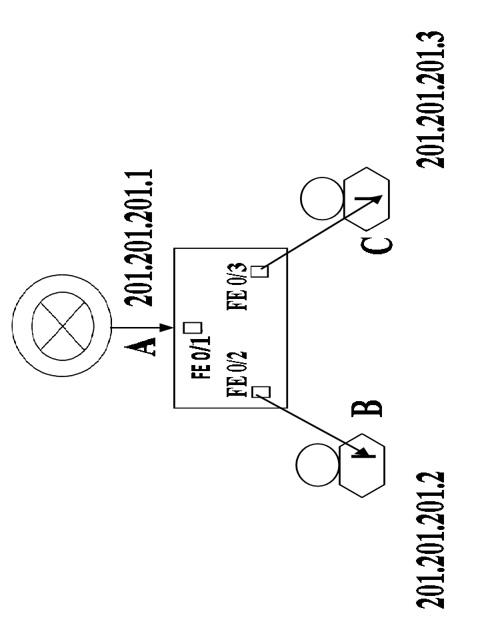
Case I:
Pinging two IP Host Addresses within the same Network



STEPS | DESCRIPTION FOR CASE I | PICTURE
 | 201.201.201.2 PING 201.201.201.3
 | 201.201.201.2 Performs the “Logical AND” on the SIP and DIP.  The Logical AND pulls out the IP Network Address where those IP Host Addresses reside in. | 201.201.201.2 201.201.201.3  255.255.255.0 255.255.255.0  201.201.201.0 = 201.201.201.0  Same IP Network Address
 | Do you need to use the default Gateway “Yes” or “No”?  No  The Default Gateway is the Router Interface IP Host Address. Therefore, every device with a NI card will have the same Gateway IP Address. | Why No?  Because both IP Host Addresses have the same IP Network Address
201.201.201.2 builds a 802.3 Ethernet Frame (ECHO - REQUEST)
DMAC | SMAC | L | SIP | DIP | PAYLOAD
? | B | E | 201.201.201.2 | 201.201.201.3 | PING  ECHO - REQUEST
 |  | N
 |  | G
 |  | T
 |  | H

 | Look in ARP table for the IP Host Address in the DIP field and if it is found use its Associated MAC Address as the Directory MAC Address |  | 5.5  If it is not found, then proceed to suspend the ping
 | IP Host Address not found – Ping Suspended
201.201.20.2 builds a 802.3 Ethernet Frame (ARP - REQUEST)
DMAC | SMAC | L | SIP | DIP | PAYLOAD
FFFF  (12 F’s) | B | E | 201.201.201.2 | 201.201.201.3 | ARP - REQUEST
 |  | N
 |  | G
 |  | T
 |  | H

An example of a Broadcast Frame

 | The 201.201.20.2 - 802.3 Ethernet Frame Hits the Switch  3 – Functions:  1 – Address Learn:  Learns the source MAC and the port on which it was learnt on and put it into the MAC Table.  2 – Filter/Forward:  3 – Loop Avoidance: |  |     MAC TABLE  B FE 0/2  B FE0/2 – SMAC and Port on which it was learnt
8-2 | Filter/Forward:  Look in the ARP table for the DMAC field and if there are all 12 F’s, F stands for flood, and flood means send a copy of the frame out of every port except for the port on which it was learnt on.  Every device with a NI card, in the same network, has received a copy of the frame of 201.201.201.2 and put it in their ARP Tables. This way, if they ever want to ping 201.201.201.2 it will not be necessary to build an ARP- REQUEST/REPLY. |  | ARP TABLE  . 2 B  ARP TABLE  . 2 B  
8 – 2.2 | If they are not all 12 F’s, then look at the MAC table for a match. If it matches the IP Host Address, then this will forward the frame out of that port.  201.201.201.3 Acknowledges its IP Host Address and therefore forward the frame out of that port.  C FE0/3 – SMAC and Port on which it was forwarded |  | MAC TABLE  B FE 0/2  C FE 0/3  B FE0/2 – SMAC and Port on which it was learnt
201.201.201.3 is forced to build a 802.3 Ethernet Frame (ARP – REPLY)
DMAC | SMAC | L | SIP | DIP | PAYLOAD
B | C | E | 201.201.201.3 | 201.201.201.2 | ARP - REPLY
 |  | N
 |  | G
 |  | T
 |  | H

An example of a Unit-cast Frame

 | The 201.201.201.3 - 802.3 Ethernet Frame Hits the Switch  3 – Functions:  1 – Address Learn:  Learns the source MAC and the port on which it was learnt on and put it into the MAC Table.  2 – Filter/Forward:  C FE0/3 – SMAC and Port on which it was learnt  3 – Loop Avoidance: |  |     MAC TABLE  C FE 0/3
10-2 | Filter/Forward:  Look in the ARP table for the DMAC field and if there are all 12 F’s, F stands for flood, and flood means send out a copy of the frame out of every port except for the port on which it was learnt on. |  | ARP TABLE  . 3 C  
10-2.2 | If they are not all 12 F’s, then look at the MAC table for a match. If it matches any IP Host Address, then this will forward the frame out of that port.  201.201.201.2 Has received a copy of the frame of 201.201.201.3 and put it in its ARP Table.  C FE0/3 – SMAC and Port on which it was forwarded |  | MAC TABLE  B FE 0/2  C FE 0/3  B FE0/2 – SMAC and Port on which it was learnt
 | Un-suspend the ping
201.201.201.2 builds an 802.3 Ethernet Frame (Echo Request)
DMAC | SMAC | L | SIP | DIP | PAYLOAD
C | B | E | 201.201.201.2 | 201.201.201.3 | PING  ECHO - REQUEST
 |  | N
 |  | G
 |  | T
 |  | H

DMAC | SMAC | L | SIP | DIP | PAYLOAD
B | C | E | 201.201.201.3 | 201.201.201.2 | PING  ECHO - REPLY
 |  | N
 |  | G
 |  | T
 |  | H
201.201.201.2 builds an 802.3 Ethernet Frame (Echo Reply)


PINGING TWO IP HOST ADDRESSES IN DIFFERENT NETWORKS
202.202.202.1
202.202.202.2
FE 0/1

FE 0/2
D
E
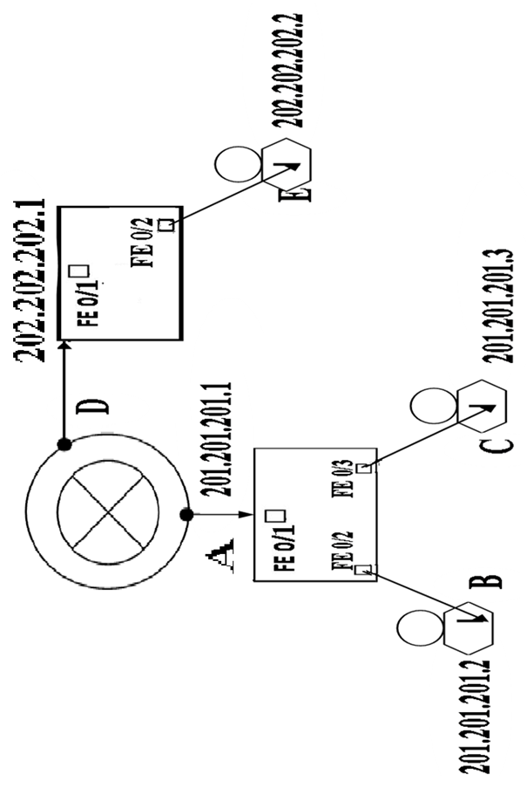
STEPS | DESCRIPTION FOR CASE II |  | PICTURE
 | 201.201.201.2 PING 202.202.202.2
 | 201.201.20.2 Performs the “Logical AND” on the SIP and DIP.  The Logical AND pulls out the IP Network Address where those IP Host Addresses reside in. |  | 201.201.201.2 202.202.202.2  255.255.255.0 255.255.255.0  201.201.201.0 = 202.202.202.0  Different IP Network Addresses
 | Do you need to use the default Gateway “Yes” or “No”?  Yes  *The Default Gateway is the Router Interface IP Host Address. Therefore, every device with a NI card will have the same Gateway IP Address. |  | Why Yes?  Because both IP Host Addresses have different IP Network Addresses
201.201.201.2 builds a 802.3 Ethernet Frame (ECHO - REQUEST)
DMAC | SMAC | L | SIP | DIP | PAYLOAD
? | B | E | 201.201.201.2 | 202.202.202.2 | PING  ECHO - REQUEST
 |  | N
 |  | G
 |  | T
 |  | H

 | Look in the ARP table for the default Gateway IP Address in the DIP field and if it is found use its Associated MAC Address as the Directory MAC Address |  |  | 5.5  If it is not found, then proceed to suspend the ping
 | Default Gateway IP Address not found – Ping Suspended
201.201.201.2 builds a 802.3 Ethernet Frame (ARP - REQUEST)
DMAC | SMAC | L | SIP | DIP | PAYLOAD
FFFF  (12 F’s) | B | E | 201.201.201.2 | 201.201.201.1 | ARP - REQUEST
 |  | N
 |  | G
 |  | T
 |  | H

An example of a Broadcast Frame

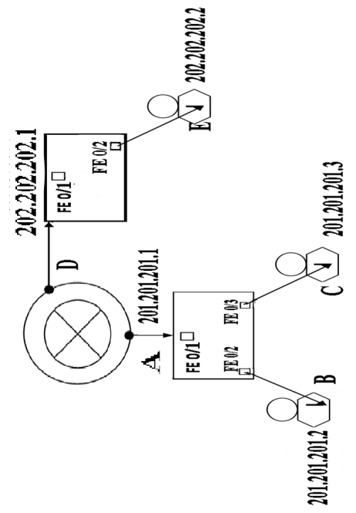
 | The 201.201.201.2 802.3 Ethernet Frame Hits the Switch  MAC TABLE  B FE 0/2  3 – Functions:  1 – Address Learn:  Learns the source MAC and the port on which it was learnt on and put it into the MAC Table.  2 – Filter/Forward:  3 – Loop Avoidance:  B FE0/2 – SMAC and Port on which it was learnt |  |   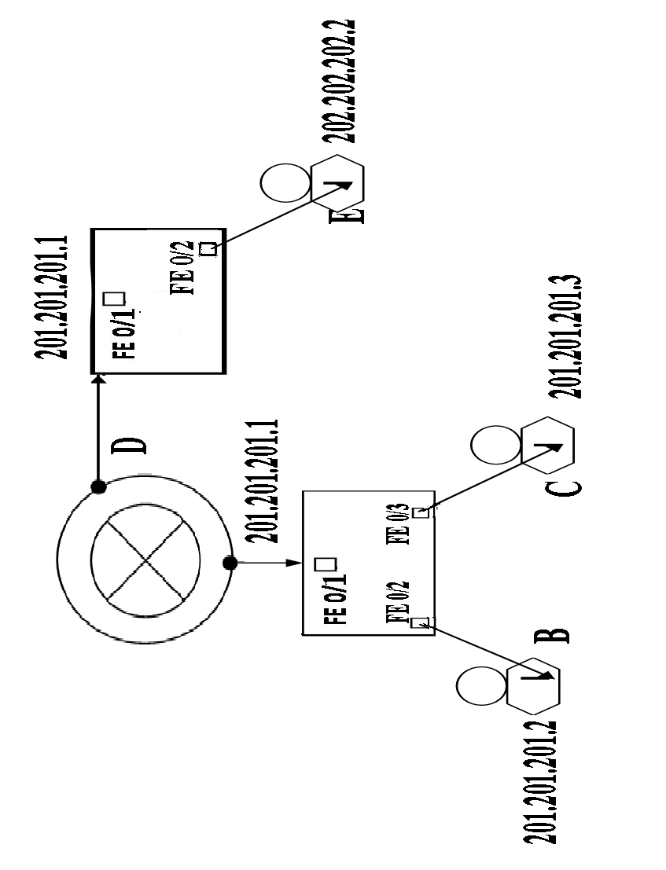
8-2 | Filter/Forward:  Look in the ARP table for the DMAC field and if there are all 12 F’s, F stands for flood, and flood means send out a copy of the frame out of every port except for the port on which it was learnt on.  ARP TABLE  , 2 B  Every device with a NI card, in the same network, has received a copy of the frame of 201.201.201.2 and put it in their ARP Tables. This way, if they ever want to ping 201.201.201.2 it will not be necessary to build an ARP- REQUEST/REPLY.  MAC TABLE  B FE 0/2  A FE 0/1 |  | ARP TABLE  , 2 B  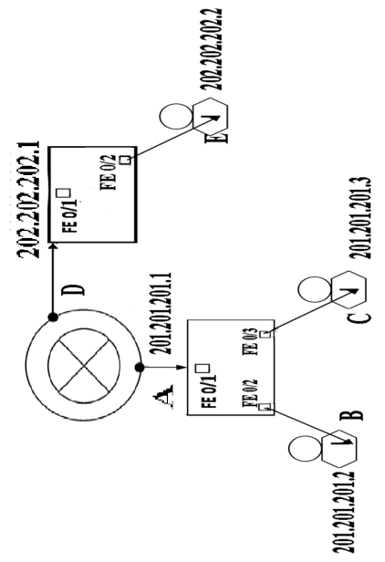  
8 – 2.2 | If they are not all 12 F’s, then look at the MAC table for a match. If it matches any IP Host Address, then this will forward the frame out of that port.  201.201.201.1 Acknowledges its IP Host Address and therefore forward the frame out of that port.  A FE0/1 – SMAC and Port on which it was forwarded |  | B FE0/2 – SMAC and Port on which it was learnt
201.201.201.1 is forced to build a 802.3 Ethernet Frame (ARP – REPLY)
DMAC | SMAC | L | SIP | DIP | PAYLOAD
B | A | E | 201.201.201.1 | 201.201.201.2 | ARP - REPLY
 |  | N
 |  | G
 |  | T
 |  | H

An example of a Unit-cast Frame

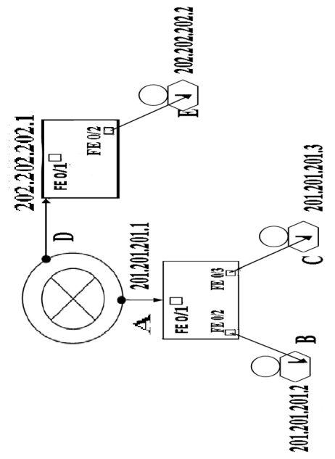

 | The 201.201.201.1 802.3 Ethernet Frame Hits the Switch  3 – Functions:  MAC TABLE  A FE 0/1  1 – Address Learn:  Learns the source MAC and the port on which it was learnt on and put it into the MAC Table.  2 – Filter/Forward:  3 – Loop Avoidance: |  | 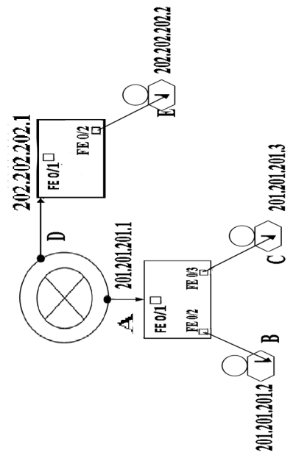  A FE0/1 – SMAC and Port on which it was learnt
10-2 | Filter/Forward:  Look in the ARP table for the DMAC field and if they are all 12 F’s, F stands for flood, and flood means send out a copy of the frame out of every port except the port on which it was learnt on. |  | ARP TABLE  . 1 A
10-2.2 | If they are not all 12 F’s, then look at the MAC table for a match. If it matches any IP Host Address, then this will forward the frame out to that port.  MAC TABLE  B FE 0/2  A FE 0/1  201.201.201.2 Has received a copy of the frame of 201.201.201.1 and put it in its ARP Tables |  | 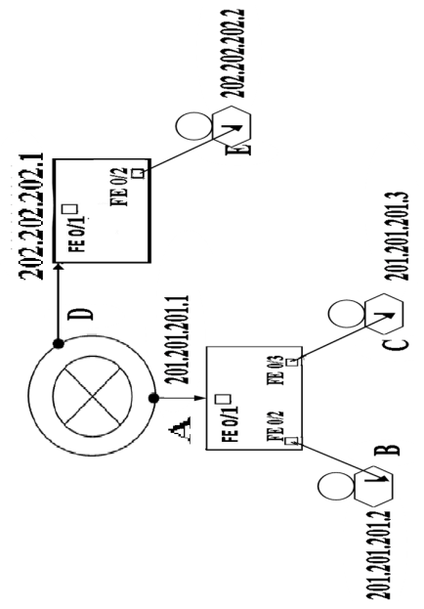  B FE0/2 – SMAC and Port on which it was learnt
 | Un-suspend the ping
A FE0/1 – SMAC and Port on which it was forwarded
DMAC | SMAC | L | SIP | DIP | PAYLOAD
A | B | E | 201.201.201.2 | 202.202.202.2 | PING  ECHO - REQUEST
 |  | N
 |  | G
 |  | T
 |  | H

201.201.201.2 un-suspends 802.3 Ethernet Frame (ECHO - REQUEST)

201.201.201.2 Echo Request Hits the Switch Hits the Switch
3 – Functions:

1 – Address Learn:
Learns the source MAC and the port on which it was learnt on and put it into the MAC Table.
2 – Filter/Forward:
Look in the ARP table for the DMAC field and if they are all 12 F’s, F stands for flood, and flood means send out a copy of the frame out to every port except the port on which it was learnt on.
3 – Loop Avoidance:

Routing Table
C 201.201.201.0//24 directly connected to Interface FastEthernet 0/0
C 202.202,202.0//24 directly connected to Interface FastEthernet 0/1

The router receives the IP packet. It Performs the Logical AND on the Dip field to pull out the IP Network Address where that IP Host Address resides in. Then, it looks in its routing table for a match. If it is found, it sends the IP packet out of that particular router interface. The SIP and DIP remain the same while the MAC Addresses change.
202.202.202.1 builds a 802.3 Ethernet Frame (ECHO - REQUEST)
DMAC | SMAC | L | SIP | DIP | PAYLOAD
? | D | E | 201.201.201.2 | 202.202.202.2 | PING  ECHO - REQUEST
 |  | N
 |  | G
 |  | T
 |  | H

 | Look in the ARP table for the IP Host Address in the DIP field and if it is found use its Associated MAC Address as the Directory MAC Address. |  |  | 14.5  If it is not found, then proceed to suspend the ping.
 | IP Host Address not founded – Ping Suspended
202.202.202.1 builds a 802.3 Ethernet Frame (ARP – REQUEST)
DMAC | SMAC | L | SIP | DIP | PAYLOAD
FFFF  (12 F’s) | D | E | 201.201.201.2 | 202.202.202.2 | ARP- REQUEST
 |  | N
 |  | G
 |  | T
 |  | H

An example of a Broadcast Frame.

 | 202.202.202.1 ARP Request Hits the Switch Hits the Switch  3 – Functions:  1 – Address Learn:  Learns the source MAC and the port on which it was learnt on and put it into the MAC Table. |     MAC TABLE  D FE 0/1
 | 2 – Filter/Forward:  Look in the ARP table for the DMAC field and if they are all 12 F’s, F stands for flood, and flood means send out a copy of the frame out to every port except for the port on which it was learnt on.  3 – Loop Avoidance: | ARP TABLE  .1 D
202.202.202.2 is forced to build a 802.3 Ethernet Frame (ARP – REPLY)
DMAC | SMAC | L | SIP | DIP | PAYLOAD
D | E | E | 201.201.201.1 | 201.201.201.2 | PING  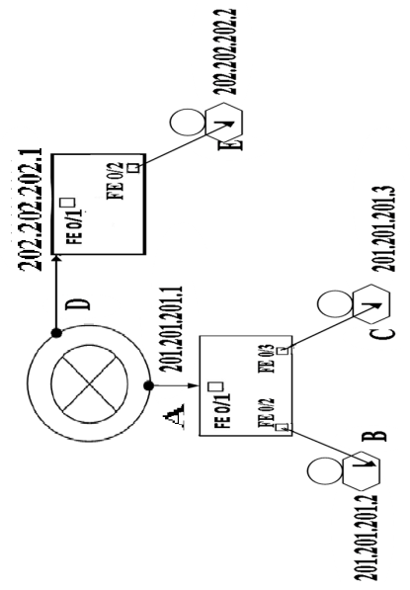  ARP - REPLY
 |  | N
 |  | G
 |  | T
 |  | H

An example of a Unit-cast Frame

 | 202.202.202.2 ARP REPLY Hits the Switch Hits the Switch  3 – Functions:  1 – Address Learn:  Learns the source MAC and the port on which it was learnt on and put it into the MAC Table. |   MAC TABLE  E FE 0/2
 | 2 – Filter/Forward:  Look in the ARP table for the DMAC field and if they are all 12 F’s, F stands for flood, and flood means send out a copy of the frame out to every port except the port on which it was learnt on.  3 – Loop Avoidance: | ARP TABLE  .2 E
 | Un-suspend the ping
202.202.202.1 Un-suspend 802.3 Ethernet Frame (ECHO - REQUEST)
DMAC | SMAC | L | SIP | DIP | PAYLOAD
E | D | E | 201.201.201.2 | 202.202.202.2 | PING  ECHO - REQUEST
 |  | N
 |  | G
 |  | T
 |  | H

 | 201.201.201.2 Echo Request Hits the Switch Hits the Switch  3 – Functions:  1 – Address Learn:  Learns the source MAC and the port on which it was learnt on and put it into the MAC Table. | 2 – Filter/Forward:  Look in the ARP table for the DMAC field and if they are all 12 F’s, F stands for flood, and flood means send out a copy of the frame out to every port except the port on which it was learnt on.  3 – Loop Avoidance:
202.202.202.2 builds a 802.3 Ethernet Frame (ECHO - REPLY)
DMAC | SMAC | L | SIP | DIP | PAYLOAD
D | E | E | 202.202.202.2 | 201.201.201.2 | PING  ECHO - REPLY
 |  | N
 |  | G
 |  | T
 |  | H

 | 202.202.202.2 Echo Reply Hits the Switch Hits the Switch  3 – Functions:  1 – Address Learn:  Learns the source MAC and the port on which it was learnt on and put it into the MAC Table. | 2 – Filter/Forward:  Look in the ARP table for the DMAC field and if they are all 12 F’s, F stands for flood, and flood means send out a copy of the frame out to every port except the port on which it was learnt on.  3 – Loop Avoidance:
DMAC | SMAC | L | SIP | DIP | PAYLOAD
? | A | E | 202.202.202.2 | 201.201.201.2 | PING  ECHO - REQUEST
 |  | N
 |  | G
 |  | T
 |  | H
201.201.201.1 builds 802.3 Ethernet Frame (ECHO - REPLY)
DMAC | SMAC | L | SIP | DIP | PAYLOAD
B | A | E | 202.202.202.2 | 201.201.201.2 | PING  ECHO - REQUEST
 |  | N
 |  | G
 |  | T
 |  | H
201.201.201.1 builds 802.3 Ethernet Frame (ECHO - REPLY)
The router looks for the Associated MAC address of the IP Host Address in the Dip field

Subnetting
205.205.205.0
N5
N3
N2
Steps | Descriptions
#1 | Count the Number of Networks
#2 | Write a formula $2^{n}$ - 2 where n is the number of host bits borrowed
#3 | Display Position Value of Host Bits
#4 | Draw a line where all the on bits of the subnet mask ends.  In the n(position where on bits end) octets and n(host bits borrowed) bits in.
#5 | Sum the On Bits in my Subnet Mask
#6 | Circle the last On Bit in my Subnet Mask
#7 | Every subnet is a multiple of my subnet 1
Note1: | You can borrow bits until the least number of bits left are two. You cannot go any further because you need bits to address your IP Host Address in your Network.
Note2: | You cannot use the first Available IP Host Address and You cannot use the last Available IP Host Address either.
204.204.204.0
203.203.203.0
202.202.202.0
201.201.201.0
N4
N1

Default Configuration Register – Dictates the Router Boot Process

Setting 0x2102 Hex – base16
4 Computers of a Router
ROM  Mini-IOS | RAM  Running-Config
FLASH  IOS | NVRAM  Startup-Config
Router Executes the Boot Process 0x2102 Dictates the following
#1 | Router Executes Boot Program – Checks Functionality of Internal Hardware by executing P.O.S.T. (Power on Self Test) in “ROM.”  Diagnostic Check.
#2 | If Hardware is okay, boot program looks in “FLASH” for router IOS
#3 | If found, IOS is loaded from “FLASH” into “RAM”
If it is not found, it goes back to ROM and executes the Mini-IOS.
Mini-IOS cannot be loaded but installed it.
#4 | IOS looks for “startup-config” file in “NVRAM”
#5 | If found, IOS loads startup-config file from “NVRAM” into “RAM,” if it is not found router goes into “set up” mode…
Boot Program
Inter Network Operating System
Indicates #s following x are Hexadecimal Characters

OSI MODEL – It is like a blue print of how to understand the functionality of Network devices.
How to troubleshoot problems

OSI MODEL
TYPE |  | DATA UNIT | No. | LAYER | FUNCTION
HOST LAYERS | A  AP  APS  APST | Data  Data  Data  Segments | L7  L6  L5  L4 | Application  Presentation  Session  Transport | Telnet, SMTP, FTP, DNS  #23 #25 #20,21 #53  ASCII, EBCDIC  ---------------------------------  TCP, UDP
MEDIA LAYERS  VS | APSTN  APSTND | Packet/Datagram  Frame  Bit | L3  L2  L1 | Network  Data Link  Physical | IP, Route  LLC, MAC  Binary Transmission
SEVEN LAYERS

FOUR LAYERS
TCP/IP MODEL
(LIVE) Live interpretation of OSI MODEL
- L4 Application
- L3 Transport
- L2 Internet
- L1 Network

L7 - Network process to application
L6 - Data representation, encryption and decryption, convert machine dependent data machine independent data
L5 - Inter-host communication
L4 - End – to –End connections and reliability, flow control
L3 - Path determination and logical addressing
L2 - Physical Addressing
L1 - Media, signal and binary transmission.

EXAMPLE OF OSI MODEL
Every layer appends a layer except the layer 1.
TCP/IP Layer 3 and 4
TCP and UDP Layer 4 Transport Protocol
TCP It is like a certified mail you get back an acknowledgement. (Connection – Oriented)
UDP It is like a regular email
(Connection – Less)

Network Applications
L3 IP Packet or Datagram
Two sub layers LLC MAC
L2 IP Packet or Datagram

L2 It is the data link layer, and the only layer that has two sub leyers LLC and MAC.
It is known as frame 802.3 Ethernet Frame.
L4 Known as segment
SMTP
All Transfer Protocol use IP
Connection – Oriented Connection – Less
TCP UDP

IP

E – MAIL - SERVER
X.X.X.X IP Host Address
randy

Example : randy@optimun.net

203.203.203.0
HUB It has no software associated to it.
EIGRP A.S. # 500
.2
.1
FE 0/0
FE 0/0
.1
.1
202.202.202.0
201.201.201.0
CHINA
USA
IP HOST TABLE
T
E
T
P
X.X.X.X

IP Host USA X.X.X.X X.X.X.X
IP Host CHINA X.X.X.X X.X.X.X

Tellnet
USA# CHINA
x.x.x.x
Show running-config
Copy-paste Note Pad Save it as Host.txt
CHINA# Copy running-config TFTP
X.X.X.X
[ CHINA-Config]
Change the name of the router to Veerpal
Veerpal# Copy TEFTP rimmomg-config
CHINA#
IP Host Table set up on one router

Router Flash Restoration Using tftpdnld via a TFTP Server

- Make physical connection from router to PC.
- Make sure that the Switch is clean.
- Download the TFTP server on the PC.
- Configure the router and the PC $\left(x.x.x.x\right)$
- Ping from Router to PC and from PC to Router to make a connection.
- Type show version and look for the image file name.
- Copy file name to the TFTP server in the following manner:
Copy Flash: _ _ _ _ _ _ TFTP
- Connect to the bad Router.
- Make sure that the cables are connected to the bad router while loading Flash to the RAM.
- Type set command to view the ROMmon environment variables.
- As shown here you must set ROMmon environment variables prior to the TFTP download.
All variable names to set for tftpdnld are case sensitive and are shown here:
rommon 3 > set
PS1=rommon ! >
IP_ADDRESS=172.18.16.76
IP_SUBNET_MASK=255.255.255.192
DEFAULT_GATEWAY=172.18.16.65
TFTP_SERVER=172.18.16.2
TFTP_FILE=quake/rel22_Jan_16/c2600-i-mz
- Type TFTPdnload
- When needed Enter y to copy the good IOS to not good Router

STP
1st Step – Identify the three Problems before STP:
- MAC Instability.
- .3 is receiving repeated copies of the same frame.
- Broad-Cast Strom (B’Storm)
2nd Step – STP Definition:
STP is a protocol that helps to avoid loops in a switched network.
3rd Step – STP Types:
- DEC – By the Dr. Radia Parlman.
- 802.1d by the IEEE.

Root Port
Because it leads to the Root Bridge
Designated Port
FE 0/2 FE 0/3

FE 0/23 FE 0/24

FE 0/2 FE 0/3

FE 0/23 FE 0/24

4th Step – STP Concept:
STP has a concept of a Root Bridge, therefore Root Bridge manages STP.

5th Step – STP Default:
STP is enabled by default. This is why every switch thinks is a Root Bridge. Nevertheless, there can only be on Root Bridge.

6th Step – STP Election Process:
When two switches are connected together it automatically starts a Root Bridge Election Process.

6.5 – STP BID (Bridge Priority – Basic MAC Address)
The switch with the lowest BID is elected as the Root Bridge.
Any other switch will become a Non - Root Bridge.

7th Step – STP Port States
- Blocking (15s)
- Listening (15s)
- Learning (15s)
- Forwarding
- Disable

7.5th – Forwarding Ports
Every Port goes into forwarding mode because the Root Bridge is sending out BPD’US.

8th Step – BPD’US
They help with the Root Bridge Election processing by advertising the Root Bridge switch to the Non-root Bridge switches.
They also help to identify loops and networks.
Variable Length Subnet Masking (VLSM)
It allows me to not waste the IP Host Addresses.
It simply means subneting a subnet.
It helps you to preserve IP Host Address and it is also called classless IP Addressing.
Help Table
Bit Value | 128 | 64 | 32 | 16 | 8 | 4 | 2 | 1
Bits Borrowed | 1 | 2 | 3 | 4 | 5 | 6 | 7 | 8
Subnet Mask | 128 | 192 | 224 | 240 | 248 | 252 | 254 | 255
Subnet Prefix/CLDR | /25 | /26 | /27 | /28 | /29 | /30
0 8 16 24 32
201 | 45 | 222 | 254 Hosts

Original Network First Di
vision: Split/24 Network 201.45.222.0/24
Into Two/25 Subnetworks
201 | 45 | 222 | 0 | 126 Hosts

201.45.22.0/25
Subnet S6
201 | 45 | 222 | 1 | 126 Hosts
Second Division: Split 201.45.222.128/25
Into Two /26 Subnetworks
201.45.222.0/25
Subnet S5
Third Division: Split 201.45.222.128/26
Into Four /28 Subnetworks

201 | 45 | 222 | 0 | 62 Hosts

201 | 45 | 222 | 1 | 62 Hosts

201 | 45 | 222 | 1 | 1 | 0 | 0 | 14 Hosts
201.45.222.192/28 S4

201.45.222.208/28 S3

201.45.222.224/28 S2

201.45.222.240/28 S1

201 | 45 | 222 | 1 | 1 | 0 | 1 | 14 Hosts

201 | 45 | 222 | 1 | 1 | 1 | 0 | 14 Hosts

201 | 45 | 222 | 1 | 1 | 1 | 1 | 14 Hosts


RARP
I Know My MAC Address but I need an IP Host Address

Recover IOS using tftpdnld from ROMMON

In Cisco 2600/2800/3800 Series Router we can recover IOS using Trivial File Transfer Protocol (TFTP) over ethernet interface using the ROMmon tftpdnld command.
tfptdnld is more faster rather than recovering IOS via Xmodem.
There are some variables to set when we want to transfer files to router using tftpdnld.
You can type tftpdnld -h
rommon 1 > tftpdnld -r
usage: tftpdnld [-hr]
Use this command for disaster recovery only to recover an image via TFTP.
Monitor variables are used to set up parameters for the transfer.
(Syntax: "VARIABLE_NAME=value" and use "set" to show current variables.)
"ctrl-c" or "break" stops the transfer before flash erase begins.
The following variables are REQUIRED to be set for tftpdnld:
IP_ADDRESS: The IP address for this unit
IP_SUBNET_MASK: The subnet mask for this unit
DEFAULT_GATEWAY: The default gateway for this unit
TFTP_SERVER: The IP address of the server to fetch from
TFTP_FILE: The filename to fetch
The following variables are OPTIONAL:
GE_PORT: Ethernet port number for download, 0 or 1 (default=0)
TFTP_MEDIA_TYPE: Media select for GE_PORT=0, 0(Copper) or 1(Fiber) (default=0)
TFTP_VERBOSE: Print setting. 0=quiet, 1=progress(default), 2=verbose
TFTP_RETRY_COUNT: Retry count for ARP and TFTP (default=20)
TFTP_TIMEOUT: Overall timeout of operation in seconds (default=7200)
TFTP_CHECKSUM: Perform checksum test on image, 0=no, 1=yes (default=1)
TFTP_MACADDR: The MAC address for this unit
GE_SPEED_MODE: 0=10/hdx, 1=10/fdx, 2=100/hdx, 3=100/fdx, 4=1000/fdx, 5=Auto (default)
Command line options:
-h: this help screen
-r: do not write flash, load to DRAM only and launch image
Below is an example in using tftpdnld to recover an IOS image name c3845-adventerprisek9-mz.124-21.bin to a Cisco 3845 router:
rommon 1 > IP_ADDRESS=171.68.171.0
rommon 2 > IP_ADDRESS=10.0.0.1
rommon 3 > IP_SUBNET_MASK=255.255.255.0
rommon 4 > DEFAULT_GATEWAY=10.0.0.13
rommon 5 > TFTP_SERVER=10.0.0.13
rommon 6 > TFTP_FILE=c3845-adventerprisek9-mz.124-21.bin
rommon 7 > tftpdnld
IP_ADDRESS: 10.0.0.1
IP_SUBNET_MASK: 255.255.255.0
DEFAULT_GATEWAY: 10.0.0.13
TFTP_SERVER: 10.0.0.13
TFTP_FILE: c3845-adventerprisek9-mz.124-21.bin
GE_PORT: Ge0/0
TFTP_MEDIA_TYPE: Copper
GE_SPEED_MODE: Auto Invoke this command for disaster recovery only.
WARNING: all existing data in all partitions on flash will be lost!
Do you wish to continue? y/n: [n]: y
Receiving c3845-adventerprisek9-mz.124-21.bin from 10.0.0.13 !!!!!!!!!!!!!!!!!!!!!!!!!!!!
File reception completed.
Copying file c3845-adventerprisek9-mz.124-21.bin to flash.
Erasing flash at 0x607c0000
program flash location 0x60440000
rommon 8 >

Introduction
This document explains how to download a software image to a Cisco 2600/2800/3800 Series Router using Trivial File Transfer Protocol (TFTP) over thefirst LAN port using the ROMmon tftpdnld command.
Notes:
- The ROMmon TFTP transfer works on the first LAN port only. However, for the Cisco 2612, you can choose the Token Ring or Fast Ethernet port.
- You can only download files to the router. You cannot use ROMmon TFTP to get files from the router.
- The transfer does not support route bridging on Token Ring ports.

Prerequisites

Requirements
There are no specific requirements for this document.

Components Used
This document is not restricted to specific software and hardware versions.

Conventions
Refer to Cisco Technical Tips Conventions for more information on document conventions.

Operation
First, you must set ROMmon environment variables prior to the TFTP download. All variable names are case sensitive.
You can view the ROMmon environment variables by using the set command, as shown here:
rommon 3 > set
PS1=rommon ! >
IP_ADDRESS=172.18.16.76
IP_SUBNET_MASK=255.255.255.192
DEFAULT_GATEWAY=172.18.16.65
TFTP_SERVER=172.18.16.2
TFTP_FILE=quake/rel22_Jan_16/c2600-i-mz
The variables to set for tftpdnld are shown here:
usage: tftpdnld [-ur]
Use this command for disaster recovery only to recover an image via TFTP.
Monitor variables are used to set up parameters for the transfer.
(Syntax: "VARIABLE_NAME=value" and use "set" to show current variables.)
"ctrl-c" or "break" stops the transfer before flash erase begins.

The following variables are REQUIRED to be set for tftpdnld:
IP_ADDRESS: The IP address for this unit
IP_SUBNET_MASK: The subnet mask for this unit
DEFAULT_GATEWAY: The default gateway for this unit
TFTP_SERVER: The IP address of the server to fetch from
TFTP_FILE: The filename to fetch

The following variables are OPTIONAL:
TFTP_VERBOSE: Print setting. 0=quiet, 1=progress(default), 2=verbose
TFTP_RETRY_COUNT: Retry count for ARP and TFTP (default=7)
TFTP_TIMEOUT: Overall timeout of operation in seconds (default=7200)
TFTP_CHECKSUM: Perform checksum test on image, 0=no, 1=yes (default=1)

Command line options:
-r: do not write flash, load to DRAM only and launch image
-u: upgrade the rommon, system will reboot once upgrade is complete
rommon 14 >
Note: As detailed in Cisco bug ID CSCdk81077 (registered customers only) , for Cisco 2600 and 1720 Series Routers running the ROM monitor commandtftpdnld, the command might report a bad checksum comparison when it loads Cisco IOS software images of Cisco IOS Software Release 12.0(2.2)T or later.
Note: As a workaround to this problem, set the ROM monitor variable TFTP_CHECKSUM to 0. This is done by defining the variable TFTP_CHECKSUM=0 from the ROM monitor set command, and then proceeding with the tftpdnld procedure.

Token Ring
The variables to set for Token Ring are shown here:
TR_1E1R_PORT | TR_SPEED_MODE
On the Cisco 2612, this variable sets the Token Ring or Ethernet port.  0 = use Ethernet port  1 = use Token Ring port  Default is 0 | For a Token Ring port, this variable sets the ring speed and duplex mode.  0 = 4 Mbps half-duplex mode  1 = 4 Mbps full-duplex mode  2 = 16 Mbps half-duplex mode  3 = 16 Mbps full-duplex mode  Default is 2

Fast Ethernet
The variables to set for Fast Ethernet are shown here:
FE_SPEED_MODE
0 = 10 Mbps half-duplex mode
1 = 10 Mbps full-duplex mode
2 = 100 Mbps half-duplex mode
3 = 100 Mbps full-duplex mode
4 = auto-negotiation
Default is 4
You must use the sync command to save ROMmon environment variables to nonvolatile RAM (NVRAM).

Example
rommon 16 > IP_ADDRESS=171.68.171.0
rommon 17 > IP_SUBNET_MASK=255.255.254.0
rommon 18 > DEFAULT_GATEWAY=171.68.170.3
rommon 19 > TFTP_SERVER=171.69.1.129
rommon 20 > TFTP_FILE=c2600-is-mz.113-2.0.3.Q
rommon 21 > tftpdnld

IP_ADDRESS: 171.68.171.0
IP_SUBNET_MASK: 255.255.254.0
DEFAULT_GATEWAY: 171.68.170.3
TFTP_SERVER: 171.69.1.129
TFTP_FILE: c2600-is-mz.113-2.0.3.Q

Invoke this command for disaster recovery only.
WARNING: all existing data in all partitions on flash will be lost!
Do you wish to continue? y/n: [n]: y

Receiving c2600-is-mz.113-2.0.3.Q from 171.69.1.129 !!!!!.!!!!!!!!!!!!!!!!!!!.!!
File reception completed.
Copying file c2600-is-mz.113-2.0.3.Q to flash.
Erasing flash at 0x607c0000
program flash location 0x60440000
rommon 22 >

Cisco Command Summary
- Cisco Router Configuration Commands - Lists how to enable and disable interfaces, add IP addresses to interfaces, enable RIP or IGRP and set passwords.
- Cisco Router Show Commands - Handy show commands to check on the status of interfaces.
- Cisco Router Basic Operations - Covers getting into and out of different modes. Also, some handy shortcut keys are included.
- Cisco Router Copy Commands - How to save and backup your router configuration and IOS file.
- Cisco Router Debug Commands - Some useful debug commands.

Cisco Router Configuration Commands
Requirement | Cisco Command
Set a console password to cisco | Router(config)#line con 0  Router(config-line)#login  Router(config-line)#password cisco
Set a telnet password | Router(config)#line vty 0 4  Router(config-line)#login  Router(config-line)#password cisco
Stop console timing out | Router(config)#line con 0  Router(config-line)#exec-timeout 0 0
Set the enable password to cisco | Router(config)#enable password cisco
Set the enable secret password to peter.  This password overrides the enable password and is encypted within the config file | Router(config)#enable secret peter
Enable an interface | Router(config-if)#no shutdown
To disable an interface | Router(config-if)#shutdown
Set the clock rate for a router with a DCE cable to 64K | Router(config-if)clock rate 64000
Set a logical bandwidth assignment of 64K to the serial interface | Router(config-if)bandwidth 64  Note that the zeroes are not missing
To add an IP address to a interface | Router(config-if)#ip addr 10.1.1.1 255.255.255.0
To enable RIP on all 172.16.x.y interfaces | Router(config)#router rip  Router(config-router)#network 172.16.0.0
Disable RIP | Router(config)#no router rip
To enable IRGP with a AS of 200, to all interfaces | Router(config)#router igrp 200  Router(config-router)#network 172.16.0.0
Disable IGRP | Router(config)#no router igrp 200
Static route the remote network is 172.16.1.0, with a mask of 255.255.255.0, the next hop is 172.16.2.1, at a cost of 5 hops | Router(config)#ip route 172.16.1.0 255.255.255.0 172.16.2.1 5
Disable CDP for the whole router | Router(config)#no cdp run
Enable CDP for he whole router | Router(config)#cdp run
Disable CDP on an interface | Router(config-if)#no cdp enable

Cisco Router Show Commands
Requirement | Cisco Command
View version information | show version
View current configuration (DRAM) | show running-config
View startup configuration (NVRAM) | show startup-config
Show IOS file and flash space | show flash
Shows all logs that the router has in its memory | show log
View the interface status of interface e0 | show interface e0
Overview all interfaces on the router | show ip interfaces brief
View type of serial cable on s0 | show controllers 0 (note the space between the 's' and the '0')
Display a summary of connected cdp devices | show cdp neighbor
Display detailed information on all devices | show cdp entry *
Display current routing protocols | show ip protocols
Display IP routing table | show ip route
Display access lists, this includes the number of displayed matches | show access-lists
Check the router can see the ISDN switch | show isdn status
Check a Frame Relay PVC connections | show frame-relay pvc
show lmi traffic stats | show frame-relay lmi
Display the frame inverse ARP table | show frame-relay map

Cisco Router Basic Operations
Requirement | Cisco Command
Enable | Enter privileged mode
Return to user mode from privileged | disable
Exit Router | Logout or exit or quit
Recall last command | up arrow or <Ctrl-P>
Recall next command | down arrow or <Ctrl-N>
Suspend or abort | <Shift> and <Ctrl> and 6 then x
Refresh screen output | <Ctrl-R>
Compleat Command | TAB

Cisco Router Copy Commands
Requirement | Cisco Command
Save the current configuration from DRAM to NVRAM | copy running-config startup-config
Merge NVRAM configuration to DRAM | copy startup-config running-config
Copy DRAM configuration to a TFTP server | copy runing-config tftp
Merge TFTP configuration with current router configuration held in DRAM | copy tftp runing-config
Backup the IOS onto a TFTP server | copy flash tftp
Upgrade the router IOS from a TFTP server | copy tftp flash

Cisco Router Debug Commands
Requirement | Cisco Command
Enable debug for RIP | debug ip rip
Enable summary IGRP debug information | debug ip igrp events
Enable detailed IGRP debug information | debug ip igrp transactions
Debug IPX RIP | debug ipx routing activity
Debug IPX SAP | debug IPX SAP
Enable debug for CHAP or PAP | debug ppp authentication
Switch all debugging off | no debug all  undebug all

